Descriptive Statistics for a List of Numbers
Quiz scores in a (fictitious) class were 10.5, 13.5, 8, 12, 11.3, 9, 9.5, 5, 15, 2.5, 10.5, 7, 11.5, 10, and 10.5. It’s hard to get much of a sense of the class by just staring at the numbers, but you can easily compute the common measures of center and spread by using your TI-83 or TI-84.
Step 1: Enter the numbers in L1.
By the way, this note uses list L1, but you can actually use any list you like, as long as you enter the actual list name in the 1-Var Stats command in Step 2. (It doesn’t matter whether there are numbers in any other list.)
Enter the data points. | 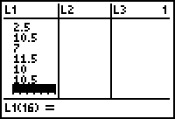[STAT] [1] selects the list-edit screen.  Cursor onto the label L1at top of first column, then [CLEAR] [ENTER] erases the list. Enter the x values.
Step 2: Compute the statistics.
Select the 1-Var Stats command. | [STAT] [►] [1] pastes the command to the home screen.
Specify which statistics list contains the data set. Show your work: write down 1-VarStats and the list name. | Assuming you used L1, enter [2nd 1 makes L1].  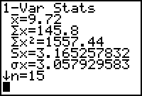Press [ENTER] to execute the command.
The important statistics are
- sample size n = 15
Always check this first to guard against leaving out numbers or entering numbers twice.
- mean x̅ = 9.72
(Use symbol μ if this is a population mean.)
- standard deviation s = 3.17
Since this data set is a sample, use S_{x} or s for the standard deviation. When the data set is the whole population, use σ_{x} or σ for the standard deviation.
If rounding is necessary, remember that we round mean and standard deviation to one decimal place more than the data.

