NAME________________________________________________ 1/5 score ____/15
http://learn.genetics.utah.edu/content/labs/gel/ This site shows how Electrophoresis works
1. How does electrophoresis separate DNA? A) by temperature B) by color C) by length
2. What pushed DNA through the gel? A) polarity B) electric current C) gravity
3. Which size DNA moves the farthest? A) Long DNA B) Medium Length DNA C) Short DNA
4. What are the five steps in running electrophoresis?
Step 1.
Step 2.
Step 3
Step 4
Step 5
5. Follow the steps to run the DNA through the gel.
6. What were the 3 lengths of “DNA in your sample? _________________ ______________ _______________

https://www.classzone.com/books/hs/ca/sc/bio_07/virtual_labs/virtualLabs.html Now solve a mystery.
Gel electrophoresis is used to help solve crimes by making a DNA fingerprint. The FBI’s forensic DNA identification system, CODIS, probes 13 parts of a person’s DNA. When 2 samples match completely at those 13 regions, there is a high probability that both samples come from the same person. If even one of the 13 regions don’t match, they samples come from different people.
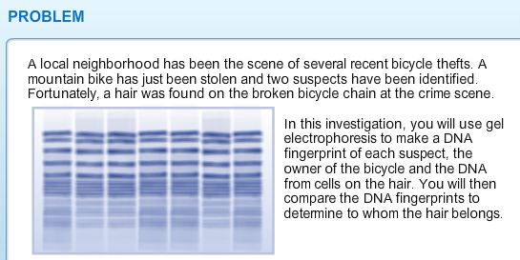
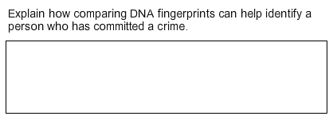

To solve this mystery, you will need to set up the electrophoresis equipment and see who’s DNA matches the DNA on the bicycle.

1. Follow instructions.
2. When it says to record in the Lab Notebook, just type any letters in the space and click the X to continue.
3. After you have run the DNA, sketch the bars on the gel and determine which suspect left his or her DNA on the bike.

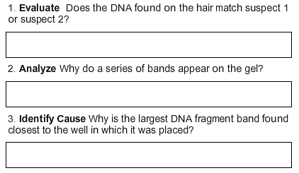
Mark the bars from the electrophoresis gel
